Abstract
While most microcontrollers can be used with a variety of clock sources, the device's internal oscillator is the preferred source if it is present, and if application requirements allow for its use. The internal oscillator is the smallest and least expensive option for clocking, as it adds no additional cost and requires no additional space, unless an otherwise appropriate device is available at lower cost without an internal oscillator. However, the R-C circuit usually used for this purpose is less accurate than a ceramic resonator, crystal, or oscillator; it also drifts more with temperature and other environmental factors. However, the more data is available on its performance, the more applications it can be used for. With adequate data, the source selection is based on known risk and performance, rather than a conservative approach to an unknown. This could be useful to anyone who uses microcontrollers in a high-interference environment, such as an RF testing lab, near a radio transmitter, or even near WiFi devices.
This experiment is designed to determine what effect radio-frequency emissions from external sources have on clock drift, and the consistency of that drift within different examples of the same MCU. Drift will be measured as percent change in number of cycles per unit time, versus the same model MCU in the control group. MCUs from 4 popular vendors will be tested in this manner: Microchip Technologies, Texas Instruments, STMicroelectronics, and NXP Semiconductor. 5 part numbers from each manufacturer will be tested, and 6 examples of each part (3 under test and 3 control.) The MCUs will be tested under RF radiation of varying frequency and power density. Several treatments will be applied to each of the experimental units, in which the temperature will be held constant, all MCUs will be powered from identical power supplies, and RF radiation of 7 selected frequencies and 4 different power densities will be applied, one treatment at a time. For each treatment, a random selection of half the EUs under test will be placed in the test chamber at a time. Frequencies will be selected to correspond to commonly used radio services or other sources of RFI, and will range from 48KHz to 5GHz. A set of power densities will be selected for each frequency, again to correspond with common real-world scenarios.

Research Plan

Carrier board: The first step will be the design of carrier boards to provide regulated power and other necessary support to the chips, such as voltage regulation capacitors, programming connections, etc. Each MCU model will have a custom board, except where a board design can be shared between multiple pin-compatible devices and remain within the manufacturer's specifications. Power will be provided at the via a linear regulator (LM317T,) with all manufacturer-specified capacitors for power quality as detailed below. Input to the regulator shall be provided by a 120V AC to 9V AC transformer, bridge rectifier, and 220μF, 16V electrolytic capacitor, in addition to the other capacitors specified for the LM317T: 0.1μF ceramic between input and ground (C_{I}), 1μF ceramic between output and ground (C_{O}), and 10μF electrolytic between adjust and ground (C_{A}). The rectifier and filter capacitors shall be located outside the test chamber to minimize interference. A discharge diode shall be provided for C_{A}, allowing current flow from Adj to Out. The MCU shall be provided the recommended/suggested supply voltage in the manufacturer's datasheet, or the center of the recommended range if no specific voltage is given, or the lowest level if several discrete levels are suggested. A temperature sensor will be installed through the bottom of the board, so that it will contact the bottom of the chip package to measure the chip's temperature. The clock out connection from the MCU, 9V power, and ground will be connected via a connector on the back of the board, to ease placement during testing and minimize interference to and from the cable. The MCU shall be obtained in the package highest in the following list in which it is available: 1. QFP / LQFP / TQFP, 2. SOIC, 3. SSOP, 4. BGA. The MCU shall be soldered to the board by IR reflow if surface mount, or wave soldering if through-hole mounted. Each board shall be made no larger than necessary to accommodate the components specified, to minimize manufacturing cost and area for potential interference.

Testing Conditions: The RF energy shall be applied to the top of the chip package, to minimize shielding and variability by other components. The bare board, with nothing covering the top surface of the package, shall be used in testing. Five concurrent tests will be run in each trial, using the test stand, to minimize the total amount of time taken running trials (and thus cost.) Each example of the various models will be placed into a different trial, to account for variation within MCUs of the same model. Data is to be analyzed for common variation between the different MCUs in a trial, versus those in other trials at the same frequency and power level. Thus, overall, the 3 MCUs under test of each model, 7 frequencies, and 4 power densities per frequency will add to a total of 336 trials of 28 treatments, with five MCUs in the test chamber at a time. In addition, 60 control MCUs will be tested in a further 12 trials. Each set within a treatment will be selected at random to avoid confounding error, and to minimize effects of transient conditions or other changes not factored into the experiment. Each MCU will be run at its maximum specified clockspeed that can be generated by the internal oscillator, with default tuning settings, and without use of a phase-locked loop (PLL.) Half-wave dipole antennas will be used for 100MHz and above, as they are small enough to be used in a test chamber [1]. For 1MHz, an inductively-loaded half-wave dipole will be used, to allow the antenna to be small enough for the chamber. A testing structure will be constructed to allow 5 chips to be tested at one time, as well as to get equal amounts of power to be transmitted to the devices under test. Under the constraint that PCB length dimensions do not exceed the lengths of the sides of the test structure, and that there is a gap on either side of the PCBs, 2 pentagons with a diameter of 1m from a vertex to the opposite side will be 3D printed from a non-conductive plastic. The dipole antenna producing RF emissions will be positioned in the geometric center of the structure, split evenly down the height of the extruded pentagons. 1 PCB per side will be attached on the inside of the pentagon using non-conductive clamps to receive treatments. While one pentagon is being used for testing, the other pentagon will be populated with the next set of boards to be tested.

Treatment Details: The experiment tests the effects of 2 factors, frequency and power density, on one dependent variable, clock drift of an MCU's internal oscillator. The 7 frequencies used represent common radio communications, broadcast, and microwave oven bands. The frequencies are 1 MHz, 100 MHz, 600 MHz, 850 MHz, 1900 MHz, 2400 MHz, and 5500 MHz. These were selected to correspond to AM broadcast, FM broadcast, UHF television broadcast, the two most common cellular bands, and the two common wireless networking (WiFi) bands. For each test frequency, a set of 4 test power density levels was selected. These correspond to power density expected at typical distances from transmitters. Distances were chosen based on effective useful range of transmission (such as 100m for WiFi, and 100km for UHF TV,) with distances typically incremented by powers of 10 from minimum to maximum. Powers of 2 were used when there were fewer than 3 orders of magnitude between minimum and maximum. Calculations were made using estimated typical antenna gain for each application, along with typical transmit power levels [2][3]. The distances and associated power levels (rounded to 2 significant digits) are as follows:

Table 1: Transmitter Distances for Power Calculation
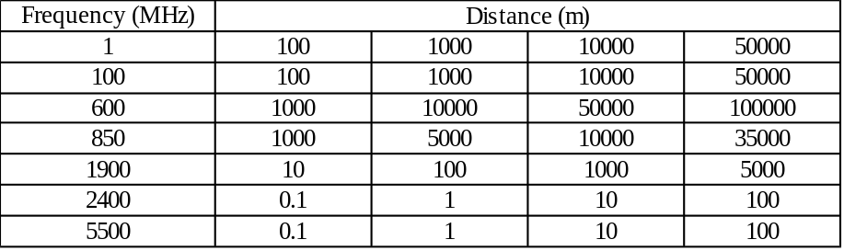

Table 2: Power Density Levels
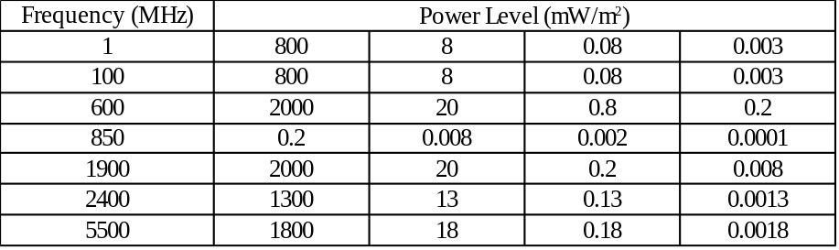

A total of 28 treatments were used, testing 3 examples each of 20 models, for a total of 1680 experimental unit-trials. As 5 devices can be tested at once, 336 actual experimental trials will be performed, along with 12 control trials. Experimental and control trials will be interleaved, 28 experimental followed by 1 control. This will avoid interference by any factors that are different at different times in the overall testing period.

Testing Location: The testing will be performed at a commercial RF testing facility, to be selected based on cost, number of suitable small test chambers available, ability to control other factors (such as temperature and unintentional RF entry into the testing facility,) and past performance working with researchers. A minimal standard will be control of temperature within ± 1º Celsius, and measurement accurate to ± 0.1ºC to allow for correction of drift caused by temperature fluctuation. Temperature measurements will be logged to allow temperature effects to be accounted for. RF measurements will be performed in the test chamber during control trials (when no RF is being generated for testing,) to determine what, if any, undesired RF interference is present. Results from prior testing of this kind will be obtained from the testing facility for evaluation of the facility, and comparison with later testing data if that facility is selected.

Device Selection: The devices selected for the experiment are produced by four of the largest microcontroller vendors in the world. They are chosen based on their feature sets, so that many applications may use the parts tested. Selection was also based on choosing newer parts more likely to be used in new designs, and in covering as many different chip families as possible, since oscillator designs are likely to be shared among different chips with otherwise closely related designs.
Table 3: Microcontrollers to be Tested
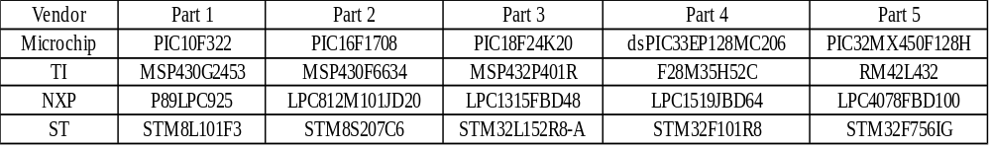
Procedure: The MCU will be placed, in its carrier board, onto the test stand. The external cable will be connected, consisting of 9V power, ground, temperature sensor signal, and clock out for measurement. A sheet of RF absorbent material (RAM) with a cutout for the chip, shall be placed onto the board to minimize interference with anything on the board other than the chip itself. The chamber will be closed, and the RF generator turned on. The power level will be allowed to stabilize for 5 minutes, then measurement will begin, using the frequency counters and dataloggers for temperature. Measurement will continue for 1 hour, during which frequency and drift measurements will be taken every minute. At the completion of measurement, the total number of cycles will also be recorded, to obtain the overall drift. All measurements will be retained for analysis at the end of the experiment, as well as for quality control while it is proceeding. The data from the first tests shall be graphed and checked for any unexpected behavior, so this can be investigated to see if it indicates a problem with the experiment. These could include missing clock cycles (due to interference from the RF in the clock signal, or a connection problem) or complete lack of clock signal, for example. Temperature data will be used to correct for clock drift caused by temperature changes rather than RF, as the response of the clock to temperature is known.

[1]Half-wave dipole:
http://www.antenna-theory.com/antennas/dipole.php
antenna-theory.com, 2015

[2]TV antennas:
http://www.americanradiohistory.com/Archive-NAB-Engineering/NAB-6th-Edition/TV-Antennas-NAB-engineering-Handbook-6th-Edition.pdf
H.E. Gihring, RCA. ca. 1967

[3]cell antennas:
https://www.tessco.com/yts/customerservice/techsupport/whitepapers/antennas.html
By Robert Wilson, TESSCO. 2010.

